E GOVERNMENT READDRESSAL SYSTEM
1. Purpose of the document
This document describes the system architecture, design decisions, component structure, APIs, data models, and non-functional aspects of the E-Government Grievance Redressal System
It is intended for:
- Developers
- Reviewers
- Interview discussions
- Maintenance & enhancement planning

2. System Overview

2.1 Business Objective:
Provide a scalable, secure, and maintainable E-Governance platform to:
- Enable citizens to register and track grievances digitally
- Ensure accountability by assigning grievances to relevant departments
- Monitor grievance lifecycle and resolution timelines
- Improve transparency through centralized tracking and notifications
- Support future growth using a microservices-based architecture

2.2 High-Level Features:
- Citizen registration and secure login using JWT authentication
- Online grievance lodging with description and document/image upload
- Centralized grievance tracking with unique reference ID (PNR-like)
- Grievance lifecycle management: Submitted → Dept_Review → Assigned → In_Progress → Work_Done → Resolved → Reopened → Escalated → Closed
- Automatic or manual department assignment for accountability
- Role-based dashboards and access control (Citizen / Officer / Supervisor / Admin/ Case Worker)
- Status change notifications via notification service
- Escalation of grievances if not resolved within defined time limits (SLAs)
- Feedback submission by citizens after grievance resolution
- Reports and analytics for department-wise and category-wise performance

2.3 Roles & Access Control:
- Citizen – Register, submit grievances, track status, and provide feedback
- Department Officer – View and resolve assigned grievances
- Supervisory Officer – Monitor grievance status and escalations
- System Admin – Manage users, departments, roles, and grievance categories
- Case Worker - Multiple per department, handled by DO.
2.4 Business Rules:
- Only authenticated users with valid roles can access system features, enforced through JWT-based role authorization.
- Citizens are the only users permitted to lodge grievances, and each grievance must be associated with exactly one category and department.
- Every grievance is assigned a unique system-generated grievance ID and timestamp at the time of submission.
- Grievances follow a strictly enforced lifecycle:
Submitted → Assigned → In Review → Resolved → Closed,
with no status skipping allowed.
- Grievances are automatically routed to the appropriate department based on category-to-department mapping.
- Only authorized department officers can update grievance status and submit resolution remarks.
A grievance is eligible for escalation if it remains unresolved beyond a predefined resolution timeframe.
- Citizens may submit feedback and ratings only after a grievance has been resolved, with limited scope for reopening.
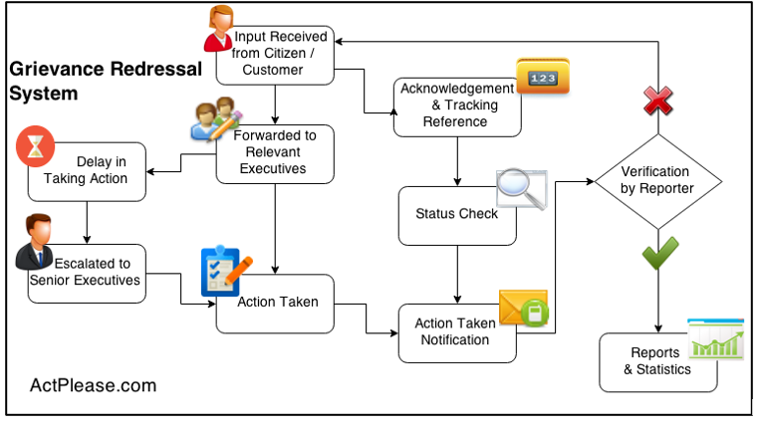
- Administrative and supervisory users have read-only access to analytics and performance reports derived from grievance data.
All grievance actions, status changes, and resolutions are logged with timestamps to ensure transparency, traceability, and auditability.

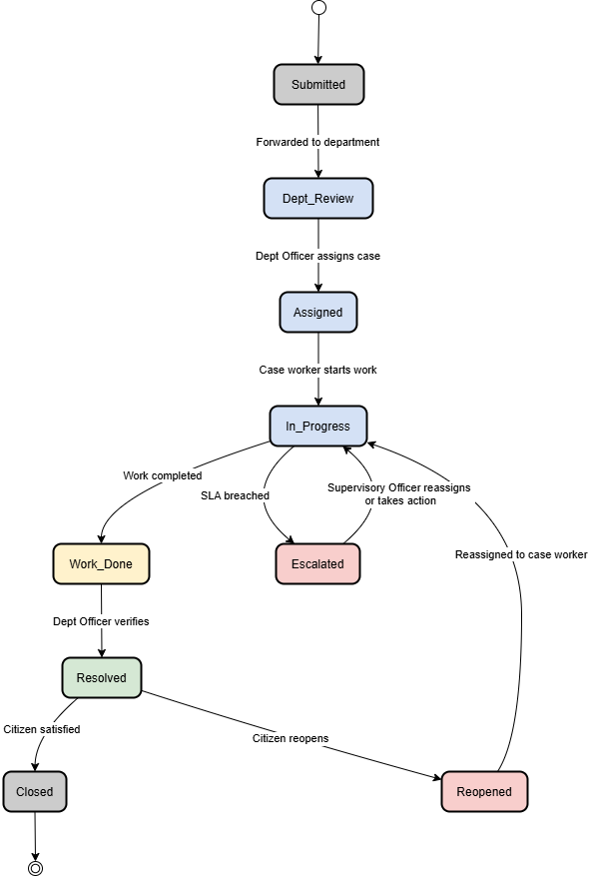

3. Architecture Diagram

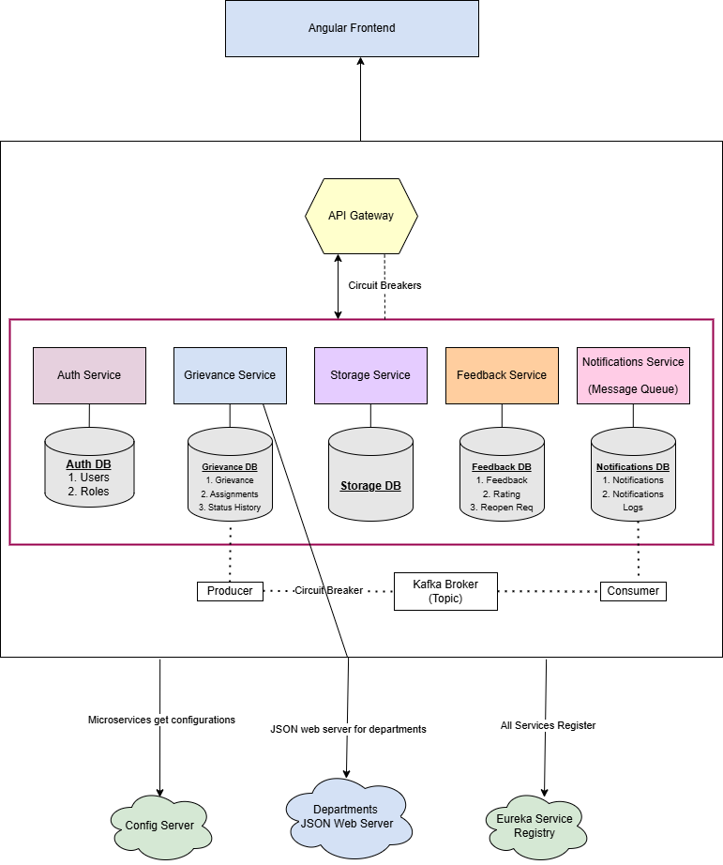

4. DB Schema for each microservice
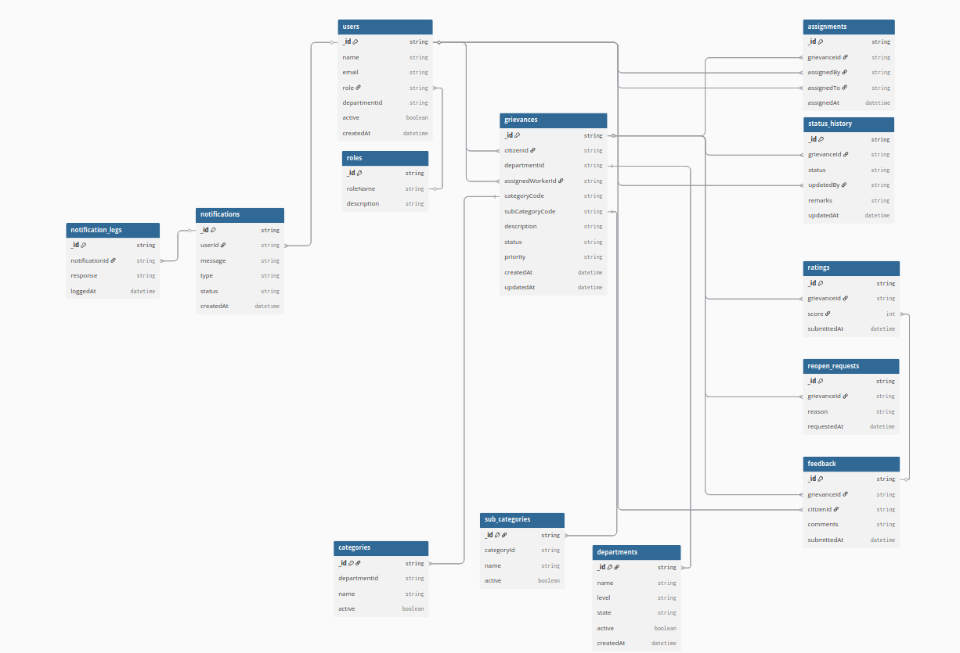

Auth Service

Users - Collection
Attribute | Type | Description
_id | String | User ID
name | String | Full name
email | String | Login email
role | Enum | CITIZEN / DO / CASE_WORKER / SO / ADMIN
departmentId | String | Nullable (for DO / CW)
active | Boolean | Enabled/disabled
createdAt | DateTime | Created timestamp

Roles - Collection
Attribute | Type | Description
_id | String | Role ID
roleName | String | Role name
description | String | Role description

Grievance Service

grievances
Attribute | Type | Description
_id | String | Grievance ID
citizenId | String | Citizen user ID
departmentId | String | Assigned department
assignedWorkerId | String | Case Worker ID
categoryCode | String | WATER, ELECTRICITY
subCategoryCode | String | SUPPLY_DELAY, CORRUPTION
description | String | Complaint text
status | Enum | GrievanceStatus
priority | String | LOW / MEDIUM / HIGH
createdAt | DateTime | Creation time
updatedAt | DateTime | Last update

assignments

Attribute | Type | Description
_id | String | Assignment ID
grievanceId | String | Grievance reference
assignedBy | String | DO ID
assignedTo | String | Case Worker ID
assignedAt | DateTime | Assignment time

status history
Attribute | Type | Description
_id | String | History record ID
grievanceId | String | Grievance reference
status | Enum | Status value
updatedBy | String | User ID
remarks | String | Optional note
updatedAt | DateTime | Timestamp

Feedback service

feedback

Attribute | Type | Description
_id | String | Feedback ID
grievanceId | String | Grievance reference
citizenId | String | Citizen ID
comments | String | Feedback text
submittedAt | DateTime | Timestamp

ratings
Attribute | Type | Description
_id | String | Rating ID
grievanceId | String | Grievance reference
score | Integer | 1–5
submittedAt | DateTime | Timestamp

reopen req
Attribute | Type | Description
_id | String | Request ID
grievanceId | String | Grievance reference
reason | String | Reopen reason
requestedAt | DateTime | Timestamp

Notification service Using kafka messenger broker this service will be the consumer
notifs
Attribute | Type | Description
_id | String | Notification ID
userId | String | Recipient
message | String | Notification text
type | Enum | EMAIL / SMS / IN_APP
status | String | SENT / FAILED
createdAt | DateTime | Timestamp

notif_logs
Attribute | Type | Description
_id | String | Log ID
notificationId | String | Parent notification
response | String | Gateway response
loggedAt | DateTime | Timestamp

5. API Design

Grievance Service

/api/grievances

 | API Name | HTTP Method | Endpoint | Request Body / Params | Success Response | Error Responses | Description
1 | Create Grievance | POST | /api/grievances/create | Body: Grievance JSON | 201 CREATED + Grievance | 400 Validation failed  500 Server error | Citizen submits a new grievance
2 | Get Grievance by ID | GET | /api/grievances/{id} | grievanceId | 200 OK + Grievance | 404 Grievance not found | Fetch a specific grievance
3 | Get All Grievances | GET | /api/grievances or /api/grievances/getAll | — | 200 OK + List of grievances | 500 Server error | Fetch all grievances
4 | Assign Grievance | PATCH | /api/grievances/{id}/assign | Query:assignedByassignedTo | 200 OK + Updated grievance | 404 Not found500 Server error | Dept Officer assigns grievance to Case Worker
5 | Update Grievance Status | PATCH | /api/grievances/{id}/status | Query:statusupdatedByremarks (optional) | 200 OK + Updated grievance | 404 Not found  400 Invalid state  500 Server error | Update grievance workflow status
6 | Get Status History | GET | /api/grievances/{id}/history | grievanceId | 200 OK + Status history list | 404 Not found | Get full lifecycle history of grievance

Department Service

/api/departments

API | Method | Endpoint | Request | Success | Errors | Description
Create department | POST | /create | Body: department | 201 | 400 | Add department
Get all departments | GET | /getAll | — | 200 | — | List departments
Get dept by ID | GET | /{id} | Path: id | 200 | 404 | Department details
Get categories | GET | /{id}/categories | Path: deptId | 200 | 404 | Categories under dept
Get subcategories | GET | /categories/{code}/subcategories | Path: categoryCode | 200 | 404 | Sub-categories
Resolve dept by category | GET | /resolve | Param: categoryCode | 200 | 404 | Used by grievance service

Feedback Service

/api/feedback

API | Method | Endpoint | Request | Success | Errors | Description
Submit feedback | POST | / | Body: feedback | 201 | 400 | Citizen rating
Get feedback | GET | /grievance/{id} | Path: grievanceId | 200 | 404 | View feedback
Analytics | GET | /stats | — | 200 | — | Reports (future)

Notification Service

/api/notifications

API | Method | Endpoint | Request | Success | Errors | Description
Send notification | POST | /send | Body: notification | 202 | 500 | Send SMS/Email
Notify on status | POST | /status-update | Body: grievanceId, status | 202 | — | Status change alert

Storage Service

/api/storage

API | Method | Endpoint | Request | Success | Errors | Description
Upload file | POST | /upload | Multipart file | 201 | 500 | Upload attachment
Get file | GET | /{fileId} | Path: fileId | 200 | 404 | Download
6. Tech Stack
Backend
- Java 21
- Spring Boot 3.2.x
- Spring Web
- Spring Data MongoDB (Reactive)
- Spring Validation
- MongoDB
- Spring Security with JWT
- Swagger / OpenAPI
- Maven
Frontend
● Angular (latest version)
● TypeScript
● Angular Material / Bootstrap
● Reactive Forms
● HttpClient & Interceptors
Database
- MongoDB (one DB per microservice)
DevOps
- Docker
- Docker Compose
- Jenkins
- SonarQube

